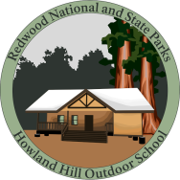
Name:

Draw Your Own Creature

Now that you have learned how animals adapt to their surroundings, create your own make-believe animal using the guidelines below.

1) Must be able to travel through the forest canopy.
2) Must be able to move fast to stay away from predators.
3) Must be able to swim.

Describe one adaptation you gave your creature:

